Nama : Helmi Efendi Lubis

NIM : 1301223338

Tugas Pendahuluan Modul 14

Header

Source

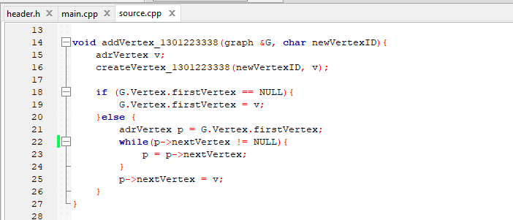

Main

Output

